|  |
| --- |
| ***Web Systems & Technologies***  ***ITL-226***      ***Lab Journal 6***                  **Student Name: M ABDULLAH BIN ABDUL AZIZ**  **Enrolment No.: 01-135231-043**  **Class and Section:BSIT5B**                **Department of Computer Science**  **BAHRIA UNIVERSITY, ISLAMABAD** |

|  |  |  |
| --- | --- | --- |
|  |  | **Lab # 6: Client-Side Scripting** |
| **Objectives:**  Learn about JavaScript        **Tools Used:**  Visual Studio |  | **Submission Date:** |
| **Evaluation:** |  | **Signatures of Lab Engineer:** |

|  |
| --- |
| **Task # 1:**  Using JavaScript print your name, University, Degree and Occupation.      **Procedure/Program:**  <!DOCTYPE html>  <html lang="en">  <head>      <meta charset="UTF-8">      <meta name="viewport" content="width=device-width, initial-scale=1.0">      <title>Display Information</title>  </head>  <body>        <h2>Personal Information</h2>      <p id="name"></p>      <p id="university"></p>     <p id="degree"></p>      <p id="occupation"></p>        <script>          // Assign values using JavaScript          document.getElementById("name").innerHTML = "<strong>Name:</strong> M ABDULLAH BIN ABDUL AZIZ";          document.getElementById("university").innerHTML = "<strong>University:</strong> Bahria University";          document.getElementById("degree").innerHTML = "<strong>Degree:</strong> Bachelor of Computer Science";          document.getElementById("occupation").innerHTML = "<strong>Occupation:</strong> IT";      </script>    </body>  </html> |

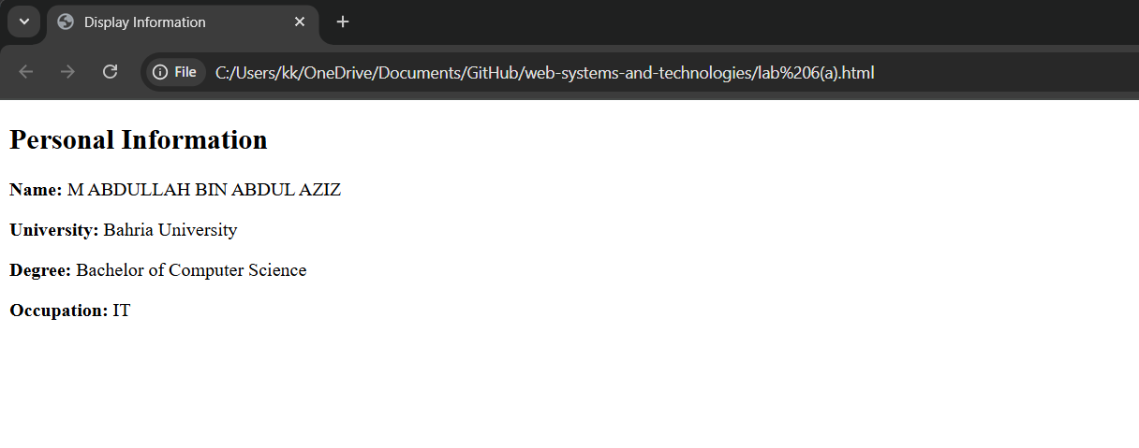

|  |
| --- |
| **Task # 2:**  Write JS code to get the length of a JavaScript object.      **Procedure/Program:**  <!DOCTYPE html>  <html lang="en">  <head>      <meta charset="UTF-8">      <meta name="viewport" content="width=device-width, initial-scale=1.0">      <title>js object</title>  </head>  <body>            <script>                  var  person = {             name: "ABDULLAH AZIZ",             university: "Bahria University",             degree: "Computer Science",             occupation: "Software Engineer"          };                     var  length = Object.keys(person).length;                     document.write("Length of the object:", length);      </script>    </body>  </html>      **Result/Output:** |

**Analysis/Conclusion:**

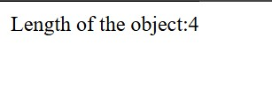

|  |
| --- |
| **Task # 3:**  Write JS code to sort an array of JS objects.      **Procedure/Program:**  <!DOCTYPE html>  <html lang="en">  <head>  <meta charset="UTF-8">  <meta name="viewport" content="width=device-width, initial-scale=1.0">  <title>js object</title>  </head>  <body>        <script> var people = [  { name: "Alice", age: 25 },  { name: "Charlie", age: 30 },  { name: "Bob", age: 22 }  ];    people.sort((a, b) => a.age - b.age);    console.log("Sorted by age:", people);      people.sort((a, b) => a.name.localeCompare(b.name));  console.log("Sorted by name:", people);  </script>    </body>  </html> |

**Result/Output:**

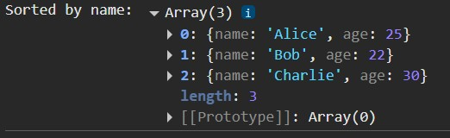

**Analysis/Conclusion:**

**Task # 4:**

Suppose you have following paragraph. Add following CSS attributes to modify the paragraph using JavaScript.

|  |
| --- |
| <p id="demo">Hello World!</p>  <script>  // Add code here  </script> |

* Use the HTML DOM to add an orange background color to <p>.
* Use the HTML DOM to left-align the text of <p>.
* Use the HTML DOM to change the text size of <p> to 30 pixels. • Use the HTML DOM to hide / unhide the <p> element when a “toggle” button is clicked.

**Procedure/Program:**

|  |
| --- |
| <!DOCTYPE html>  <html lang="en">  <head>  <meta charset="UTF-8">  <meta name="viewport" content="width=device-width, initial-scale=1.0">  <title>Modify Paragraph with JavaScript</title> <style>  #myParagraph { padding: 20px;  border: 1px solid black;  }  </style>  </head>  <body>    <p id="myParagraph">This is a sample paragraph that will be modified using JavaScript.</p>  <button onclick="toggleParagraph()">Toggle Visibility</button>    <script> |

let paragraph = document.getElementById("myParagraph");

|  |
| --- |
| paragraph.style.backgroundColor = "orange"; paragraph.style.textAlign = "left"; paragraph.style.fontSize = "30px";  function toggleParagraph() { if (paragraph.style.display === "none") { paragraph.style.display = "block";  } else { paragraph.style.display = "none";  }  }  </script>    </body>  </html> |

**Result/Output:**

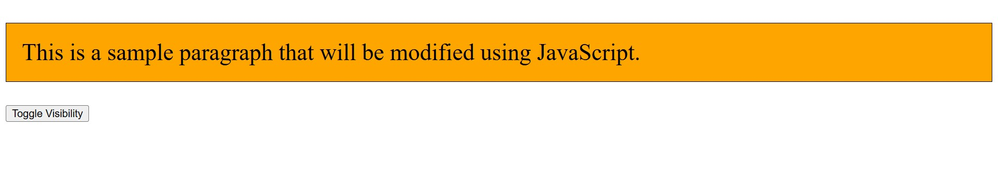



**Analysis/Conclusion:**

**Task # 5:**

Create the following GPA Calculator

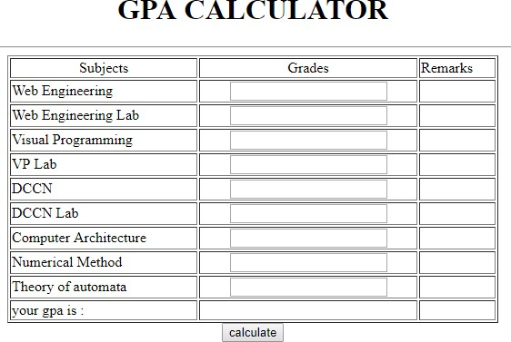

**Procedure/Program:**

|  |
| --- |
| <!DOCTYPE html>  <html lang="en">  <head>  <meta charset="UTF-8">  <meta name="viewport" content="width=device-width, initial-scale=1.0">  <title>GPA Calculator</title> <link rel="stylesheet"  href="https://cdn.jsdelivr.net/npm/bootstrap@5.3.0/dist/css/bootstrap.min.css">  <style> body {  background-color: #f8f9fa;  }  .container {  margin-top: 30px;  } table {  width: 100%; |

text-align: center;

}

</style>

|  |
| --- |
| </head>  <body>    <div class="container"> <h2 class="text-center fw-bold">GPA CALCULATOR</h2>  <table class="table table-bordered">  <thead>  <tr>  <th>Subjects</th>  <th>Grades</th>  <th>Remarks</th>  </tr>  </thead> <tbody>  <tr>  <td>Web Engineering</td>  <td><input type="text" class="form-control grade-input"></td>  <td class="remark"></td>  </tr>  <tr>  <td>Web Engineering Lab</td>  <td><input type="text" class="form-control grade-input"></td>  <td class="remark"></td>  </tr>  <tr>  <td>Visual Programming</td>  <td><input type="text" class="form-control grade-input"></td>  <td class="remark"></td>  </tr>  <tr>  <td>VP Lab</td>  <td><input type="text" class="form-control grade-input"></td>  <td class="remark"></td>  </tr>  <tr>  <td>DCCN</td>  <td><input type="text" class="form-control grade-input"></td>  <td class="remark"></td>  </tr>  <tr>  <td>DCCN Lab</td>  <td><input type="text" class="form-control grade-input"></td> |

<td class="remark"></td> </tr>

<tr>

|  |
| --- |
| <td>Computer Architecture</td>  <td><input type="text" class="form-control grade-input"></td>  <td class="remark"></td>  </tr>  <tr>  <td>Numerical Method</td>  <td><input type="text" class="form-control grade-input"></td>  <td class="remark"></td>  </tr>  <tr>  <td>Theory of Automata</td>  <td><input type="text" class="form-control grade-input"></td>  <td class="remark"></td>  </tr>  <tr>  <td><strong>Your GPA is:</strong></td>  <td colspan="2"><strong id="gpa-result">-</strong></td>  </tr>  </tbody>  </table>  <button class="btn btn-success w-100" id="calculate-btn">Calculate</button>  </div>    <script> document.getElementById("calculate-btn").addEventListener("click", function() { const gradeInputs = document.querySelectorAll(".grade-input"); const remarks = document.querySelectorAll(".remark"); let totalPoints = 0; let totalSubjects = 0;    // Grade-to-GPA mapping const gradePoints = {  "A+": 4.0, "A": 3.7,  "B+": 3.3, "B": 3.0,  "C+": 2.7,  "C": 2.3,  "D": 2.0,  "F": 0.0  }; |

gradeInputs.forEach((input, index) => {

let grade = input.value.toUpperCase().trim();

|  |
| --- |
| if (gradePoints.hasOwnProperty(grade)) { totalPoints += gradePoints[grade]; totalSubjects++;    // Assign Remarks if (grade === "A+" || grade === "A") { remarks[index].innerText = "Excellent"; remarks[index].style.color = "green"; } else if (grade === "B+" || grade === "B") { remarks[index].innerText = "Good"; remarks[index].style.color = "blue"; } else if (grade === "C+" || grade === "C") { remarks[index].innerText = "Satisfactory"; remarks[index].style.color = "orange";  } else if (grade === "D") { remarks[index].innerText = "Pass"; remarks[index].style.color = "brown";  } else { remarks[index].innerText = "Fail"; remarks[index].style.color = "red";  } } else { remarks[index].innerText = "Invalid Grade"; remarks[index].style.color = "red";  }  });    // Calculate and display GPA let gpa = totalSubjects > 0 ? (totalPoints / totalSubjects).toFixed(2) : "N/A"; document.getElementById("gpa-result").innerText = gpa;  });  </script>    </body>  </html> |

**Result/Output:**

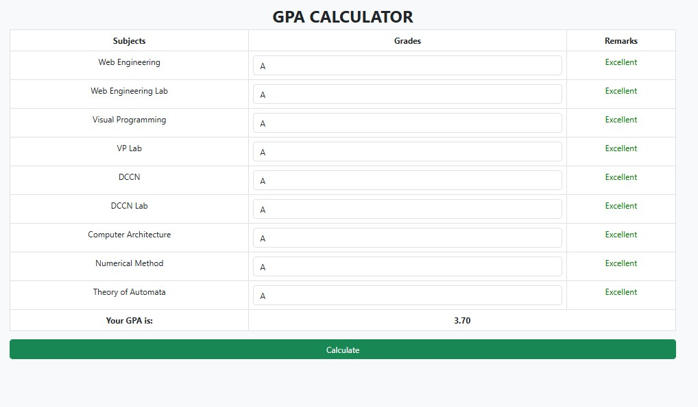

**Analysis/Conclusion:**